**Slow Code Execution Method:**

I waited over 2 hours to run Notebooks 4,6,7 & 8 then I thought something was wrong so I checked the system properties and saw that my computer was at 100% CPU usage 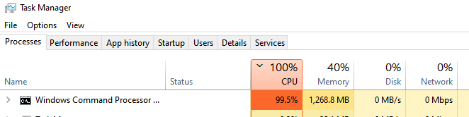

**Faster Code Execution Method:**

Bought the Google Colab Pro Subscription, uploaded the dataset onto google drive. Changed the run time environment to be the GPU instead of the CPU

|  |  |
| --- | --- |
|  |  |

Modified the Jupyter notebook code so that the dataset loads correctly in Google Colab

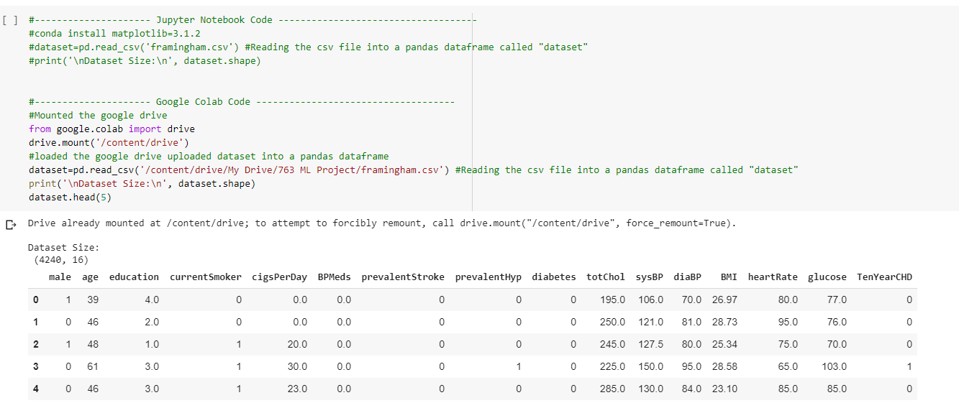

Checked the system properties to verify that I was using GPU instead of CPU for code execution this time.

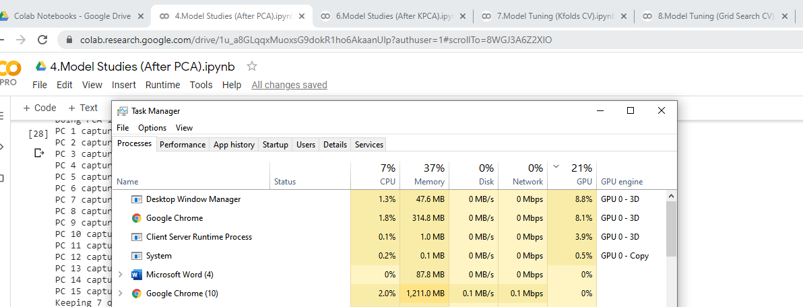

**Code Updates for Computation**

